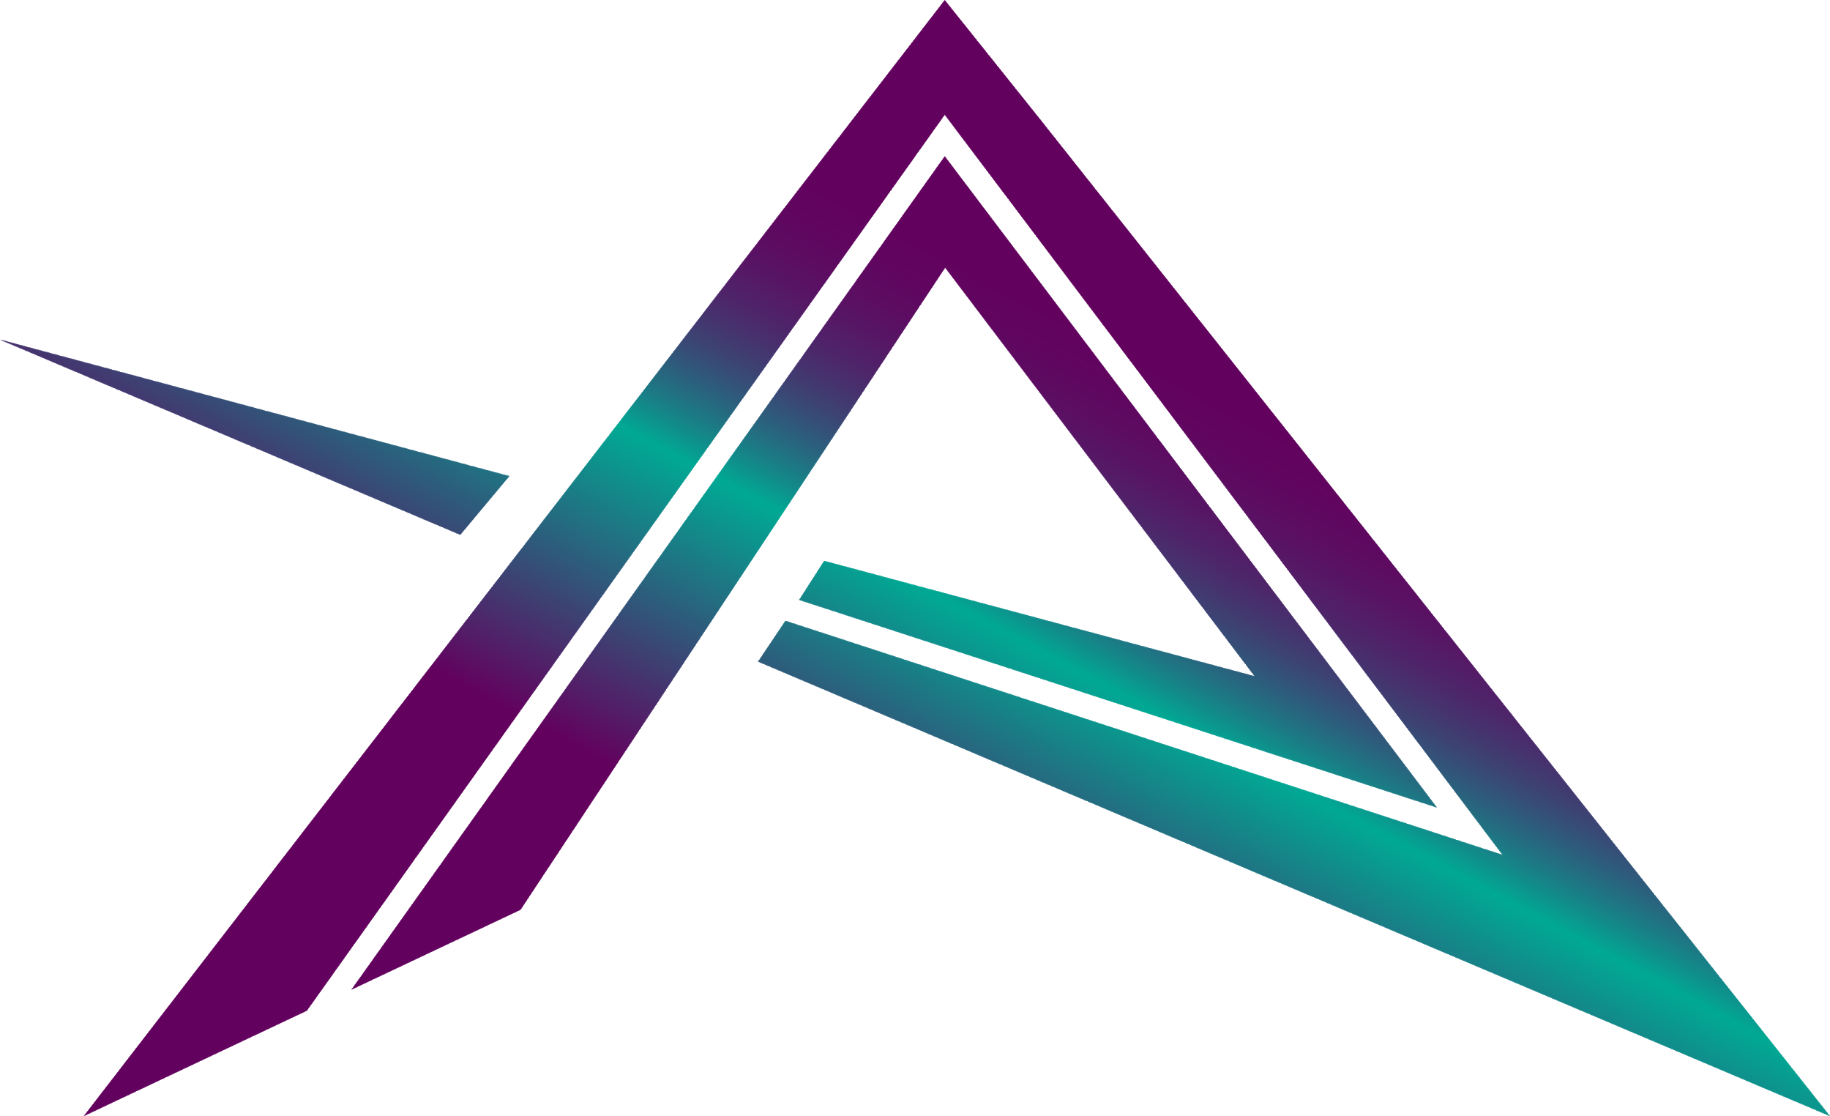

Eidoo — May Earned Media Article #2

3 June 2021

Prepared by AmaZix

Is the NFT Going to Crash or Are We Seeing a Consolidation?



Source:  
<https://christophersalem.com/how-to-revitalize-your-company-from-stagnation/>

Reading some sources in the crypto community it seems that one can hardly leave home anymore without seeing non-fungible tokens possibilities everywhere. At the same time, in other not-so-benign environments, they talk about NFTs as the next phantom menace from the dark side of finance.

So, what’s it all about? Where are we on the hype curve? And is there a reason for all the hype? First of all, let's look at what NFTs can be (and what they cannot) to determine if there really is a basis to back up the promises being made.

# What Do NFTs Do?

Let's put the NFT philosophy aside for a moment. Non-fungible tokens are defined primarily by the characteristics set forth in three separate ERCs:

1. [ERC 721](https://eips.ethereum.org/EIPS/eip-721): The original definition of NFTs. The major novelty of this ERC with respect to the typical ERC 20 standard is that these tokens do not have decimals. You can count them, but you cannot divide them.
2. [ERC 777](https://eips.ethereum.org/EIPS/eip-777): Definition of features added to the NFTs to improve their management. Introduces hooks as a connection point for smart contracts and addresses to react when an NFTs uses a contract compatible with this standard.
3. [ERC 1155](https://eips.ethereum.org/EIPS/eip-1155). Several non-fungible tokens’ use cases can be defined within the same contract. For practical purposes, this means that NFTs can share attributes as classes or groups of NFTs.

That's it. This is what NFTs do — very brief terms — and why they are used to represent a whole separate class of assets. The last point is what is behind the boom and the hype we see in the last months.

# Is Art Mightier Than the Sword?

Yes, the hype is real because the new projects are raising a lot of interest. In the general media, this interest in non-fungible tokens is mainly reflected in projects related to art or collectibles. At the same time, the reality is that the projects with a more innovative vision are coming from the gaming sector.

One may be very tempted to consider that these are just games but in reality, while art in NFTs makes the headlines, gaming gets the money. We are talking about a sector that moves $178 billion annually. The future of the sector looks even better, however, if we look at the [total number of users](https://www.statista.com/topics/1551/online-gaming/) it had access to in 2020 — 938 million customers. That is a lot of potential non-fungible token technology users. Many of them are willing to pay for their avatars to be cooler and have fatter swords.

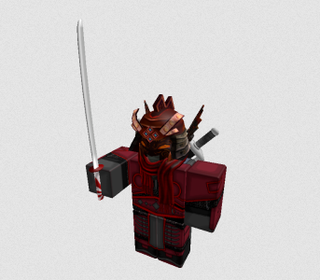

“I am not satisfied with my sword.”

Source: <https://tr.rbxcdn.com/3551af254864fa8392f9f5e378d89dfd/352/352/Avatar/Png>

# Unexploited Non-Fungibility

But enough of all this data that has the bad habit of contradicting our prejudices. Hold on to your tokens because now, mate, we are going to speculate thanks to the magic words: *What if*.

Entering now the tempestuous world of crazy ideas, we could start the journey by asking ourselves if we are utilizing all the possibilities of the non-fungible tokens. The answer to this question, we can guess, is a resounding “no”. We may be using NFTs merely for the obvious, leaving out the areas where NFTs could become the norm. We can look at it in the following way.

What if we split everything? What if we view NFTs only as the part that represents indivisible properties and the rest of the attributes could be more variable to be separated? What kind of assets could be represented by this data structure? It could be that we are grossly underutilizing this useful crypto tool.

Moreover, we talk much about non-fungible tokens as an asset, but what about the owners, the users? Aren’t they non-fungible too? Can this change how we understand digital identity?

# NFTs Out of the Digital Economy

So far, to define identity, we have always relied on some kind of physical support to declare the identity, usually cards or documents. But, with digital identity, we use electronic signatures also on cards or mobile devices.

The question is, does that identity represent you or the person who has the card? Or maybe it stands for the device?

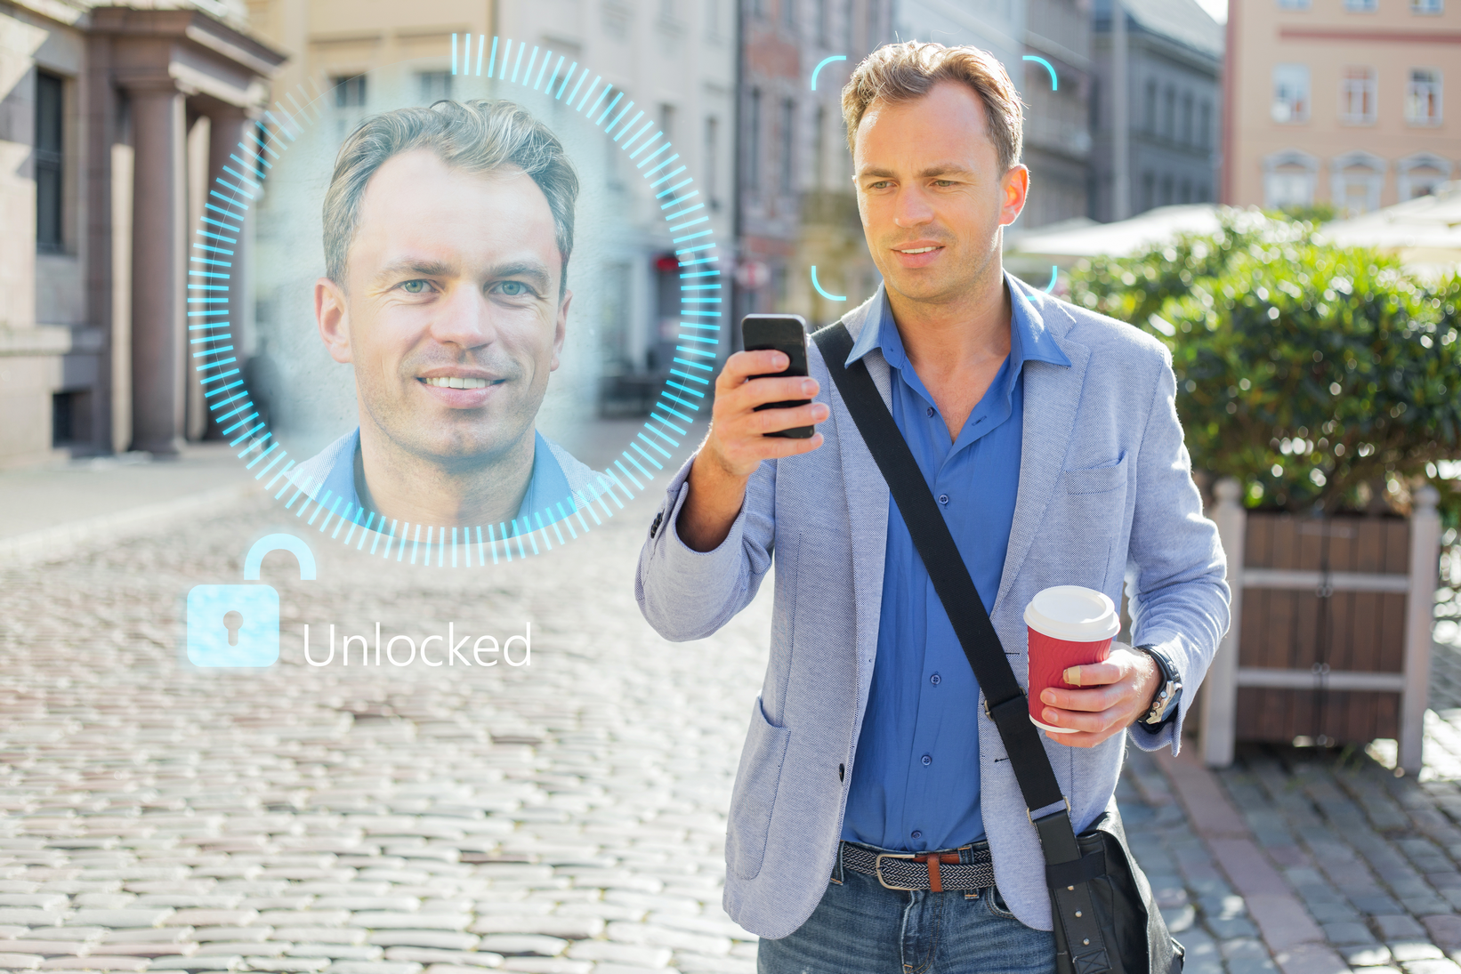

Source: <https://www.canva.com/photos/MADesP-KSXI-man-unlock-his-mobile-phone-with-facial-recognition-and-authentication-technology/>

In the case of digital identities that use a mobile phone as a means of authentication, identity is assigned to the device, so whoever has the device has the identity. The identity itself is indivisible (non-fungible token alert), but the attributes that can be assigned to it could vary depending on the type of authorization it provides, be it voting, driving a car, or paying taxes (metadata). One of these attributes could be the identification of the device or devices that may be involved in authenticating the identity of a user or owner.

Another under-exploited aspect of non-fungible tokens is their potential as a tool for the financial sector. ERC20 tokens were well suited to represent shares or divisible assets, but what would an indivisible financial asset look like? This type of concept is better suited to the intangible aspect of assets, one that, although considered in every negotiation, is not usually embodied in a contract. We refer to ideas, organizations, structures, or contacts that make it possible for a project of any kind to be delivered.

There has been speculation on the possibility of making real estate a non-fungible token but, what about the idea of the building, the design it contains? If we think of a project as a hierarchical set of contracts and assets, the NFTs could be part of the set in those aspects that are more difficult to define and assess.

The last aspect to mention is the more social part of the economic agreements — the favors, the contacts. Deals do not occur if the right parties do not meet, and this is possible in some circumstances through intermediaries who create the right forum for consensus to happen. Again an intangible and binary asset, therefore another possible candidate for non-fungible token. Either it exists or it does not.

Of course, all these are just notes, somewhat far-fetched ideas, but applying the possibilities that current or future implementations of NFTs could make them something that goes far beyond buying a special jpg file. In any case, it would be a future based on the consolidated success of the NFTs in the gaming world, where they have found the perfect environment to continue growing for the moment.

It is possible that as the applications being developed for NFTs evolve, we could see DeFi wallets with support for non-fungible tokens, such as [Eidoo wallet](https://eidoo.io/crypto-wallet) with its NFT manager or [Metamask](https://metamask.io/), become more than just wallets.

It seems that it is needed, wouldn’t you agree?